ADMIN PANEL??????????

It contain the following things??

Login Page:

==Wellcome screen containing user name and password with a suitable pic.

==after the login uname and password should verified with db either it is correct or not.

==switch to admin panel name Wellcome to cpanel of SaveHuman.

==we have following things.

**Add a bood stock**(Red buttons containing white text of (ad--) )

When clicked it appears a form.

Asking to plz enter

Blood group,quantity,d

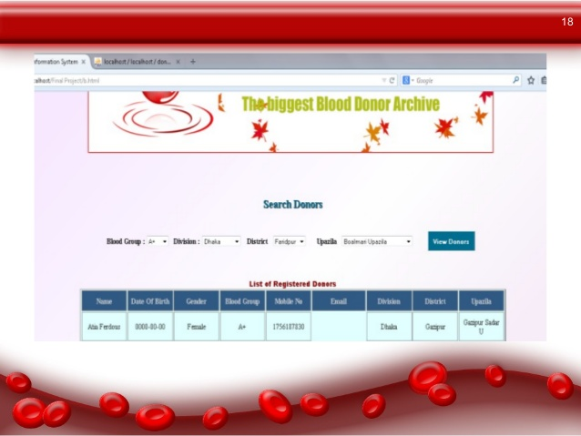

**Logo pic :**

 

**HOME:**

**On the side of slider or below**



**When clicked switch to reg(as a donor) page**

**Home page text with Pics**

# **Welcome to Save Human Blood Bank Islamabad-**

# **Blood Donors Network**

We are part of “Volunteer for a Better Pakistan”, where we work towards strengthening a technology-linked platform aimed at building a country-wide network of blood donors. Till date, through this initiative thousands of people joined and many lives have received a fresh gush of blood and lives !

*Why should we be concerned about donating blood?*

* Our nation requires 4 Crore Units of Blood while only 40 lakh units are available
* Every two seconds someone needs Blood
* There is no substitute for Human Blood. It cannot be manufactured
* Blood donation is an extremely noble deed, yet there is a scarcity of regular donors across Pakistan.

We focus on creating & expanding a virtual army of blood donating volunteers who could be searched and contacted by family / care givers of a patient in times of need.

The ingenuity of the **SaveHuman Islamabad -Blood Donors Network** is that it simply requires a volunteer to register on [www.saveHuman.org](http://www.saveHuman.org) and submit his/her contact details. Save-human collect or store blood. Blood being a highly perishable, we insist that it should be stored in the best vessel – The Human Body!

Through this digital platform, we urge you to fulfill your supreme duty as a human being; to save a life, by becoming a proud registered volunteer.

* *You may*[*register*](http://savelifeindia.org/donor/donorsignup.php)*as blood donor (Your 1 unit of blood can save 3 lives)*
* *Share opportunity with others – Build blood donors network in your city/town by clicking  “Register Your friend”*
* [*Refer*](http://www.savelifeindia.org/refer-to-friend/)*this website to all the people you know. They may be interested in becoming part of this noble cause.*
* *Use this site extensively to*[*search*](http://savelifeindia.org/donor/search-donors.php)*for blood donors on behalf of family, friend or acquaintance.*
* *========================================================================*

fa fa-envelope

**Donor Registration??(NAV-BAR)**

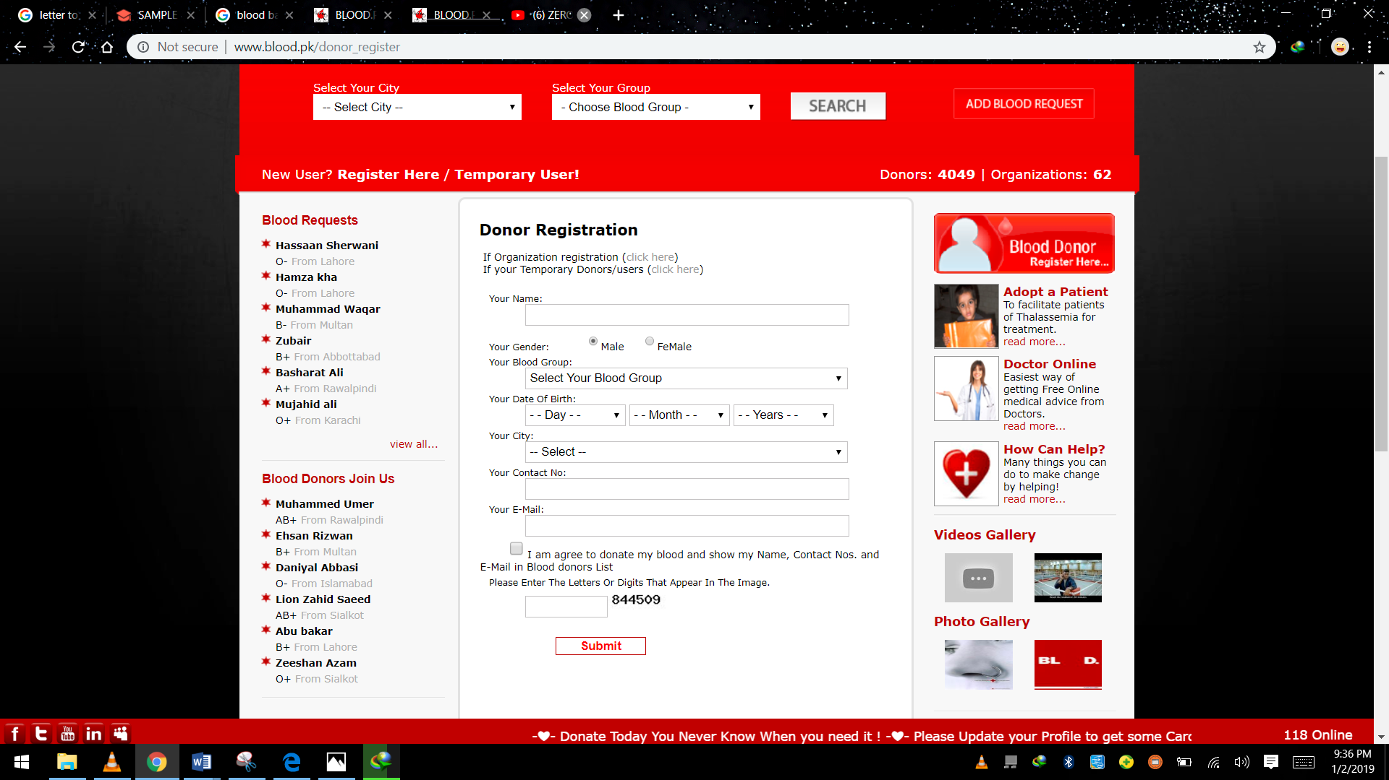

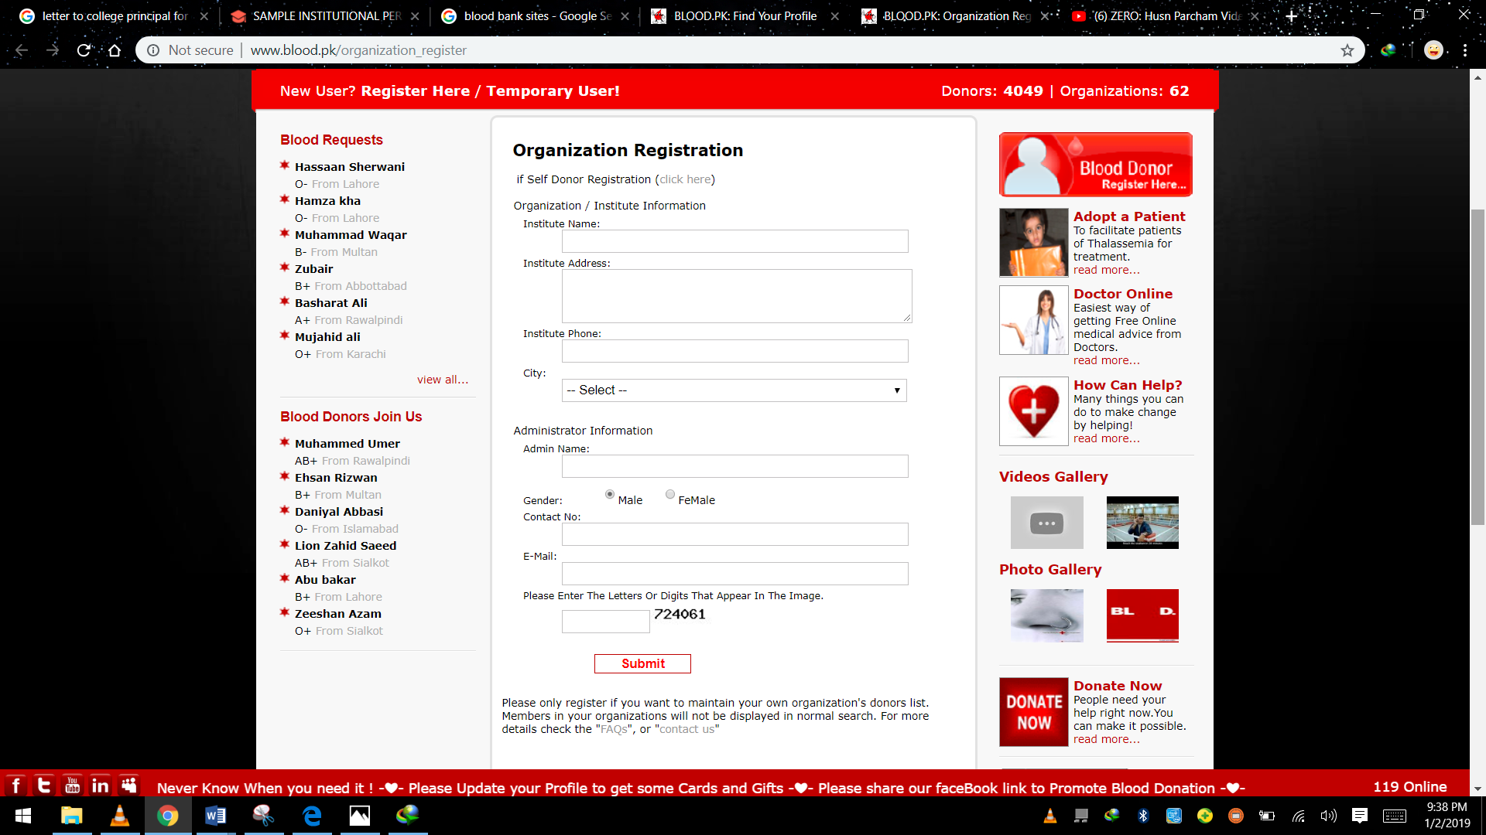

**Slider Pics:**

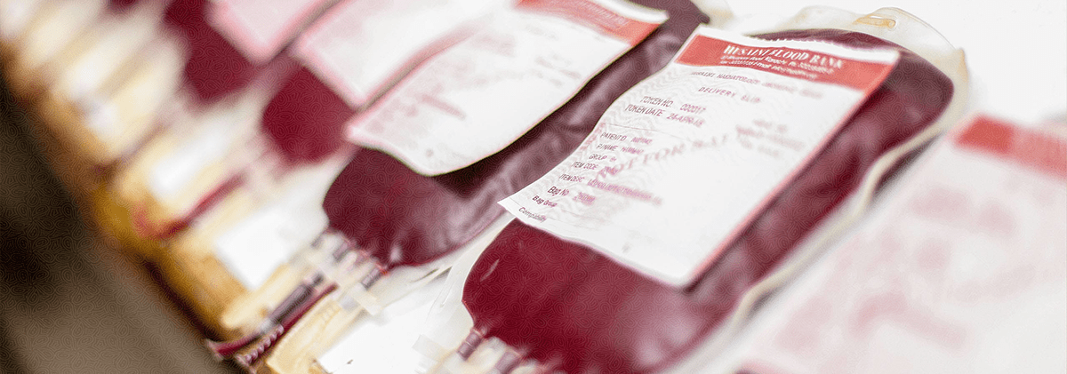

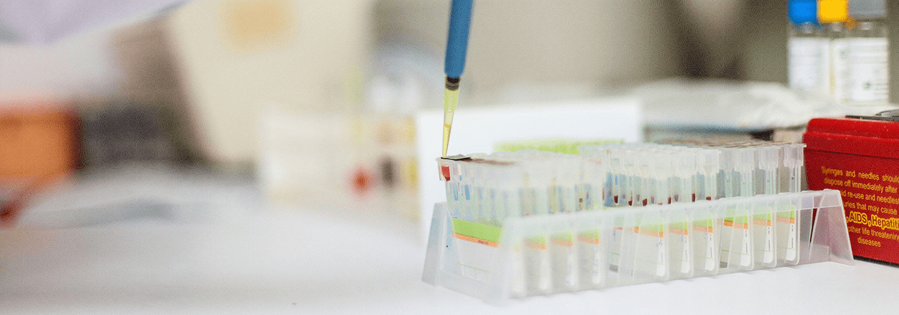

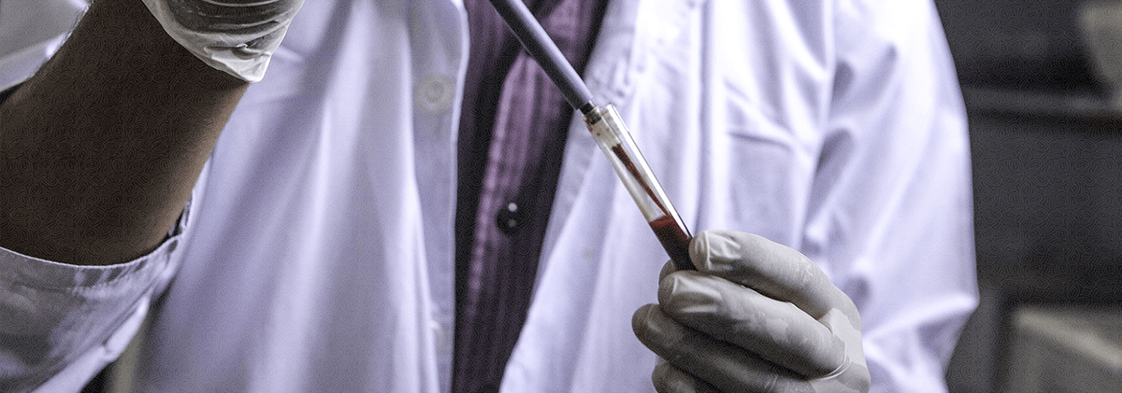

**Footer**

# Copyrights - Divisions of SaveHuman Blood Bank.

# **43-Bahria Town,**

# **Ali Mosque Road, Islamabad- Pakistan.  (Helpline) 111 - 111 - 422 l Fax:+92.21.32237735 l Email:** [**lab@SaveHuman.org**](mailto:lab@SaveHuman.org)

**About us (The navbar component)**

"We pride ourselves in providing the finest medical services to   
promote health and wellbeing for all”

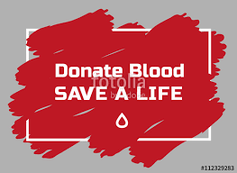

Save Human was founded in 2019 by Mr. Sher Muhammad at his clinic   
in Double Road,Rawalpindi with the support of Mr. Usman Ali.  
 chairman of Save Human trusts. The foresight, dedication and pioneering efforts of the then trustees lead to the formation of SaveHuman Blood Bank, an organization now best known to provide excellent medical services to the masses.

**Emergency number(NAVBAR---)**

|  |  |  |
| --- | --- | --- |
| **Sr.** | **Blood Banks - Lahore** | **Contact No** |
| 1 | AL Khidmat Blood Band | 042-37235982 |
| 2 | Khan Blood Bank. | 042-35863950 |
| 3 | Hussain Blood Bank | 042-6362152-59 |
| 4 | Hilal-e-Ahmar | 042-36304702 |
| 5 | Lady Willington Hospital | 042-37659001 |
| 6 | Mayo Hospital | 042-99211104 |
| 7 | Minhaj-Ul-Quran Blood Bank | 042-37230932 |
| 8 | Pakistan Blood Donation Society | 042-37598807 |
| 9 | Red Cresent | 042-36304702-03 |
| 10 | Services Hospital | 042-37588351 |
| 11 | Shaukat Khanum Memorial | 042-35180725-29 |
| 12 | Sundas Foundation | 042-37565440 |
| 13 | Sundas Foundation | 042-37539232-3 |
| 14 | Suryia Azeem Blood Bank | 042-37120004-05 |
| 15 | Venus Blood Bank | 042-37223466 |
| 16 | General Hospital | 042-35810894 |
| 17 | Meo Hospital | 042-99211104 |
| 18 | Fatmid Blood Transfusion | 042-35863950 - 042-35853491 |
|  |  |  |

**The lower marquee(Above Red Footer)**

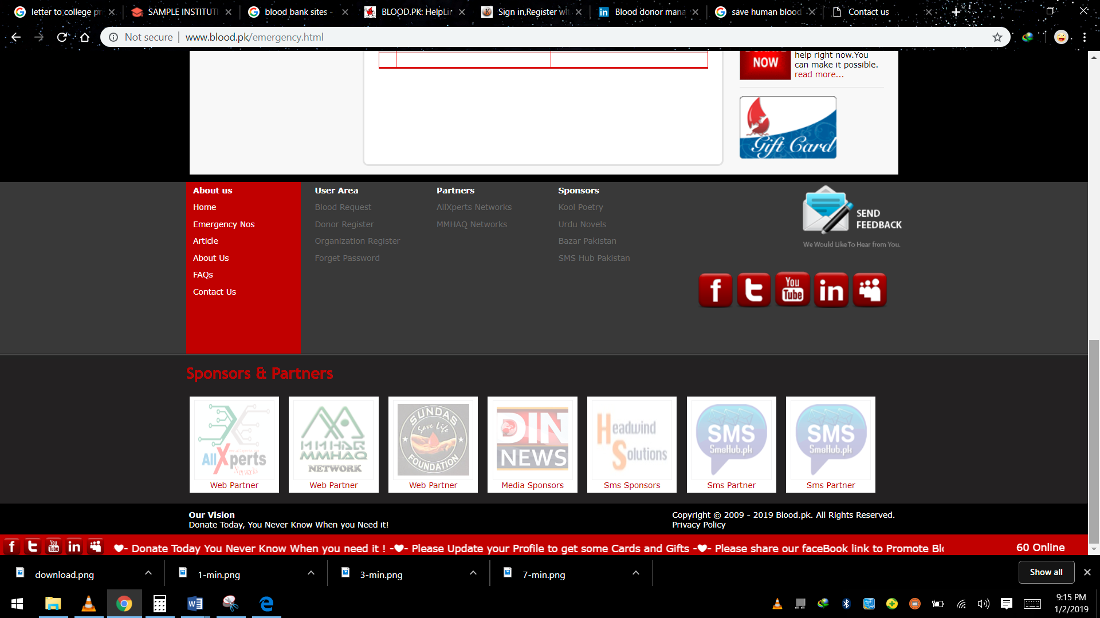

**Contact us The NAV-BAR**

